Task 1

Question 1

- Select all data from the LOCATIONS table and

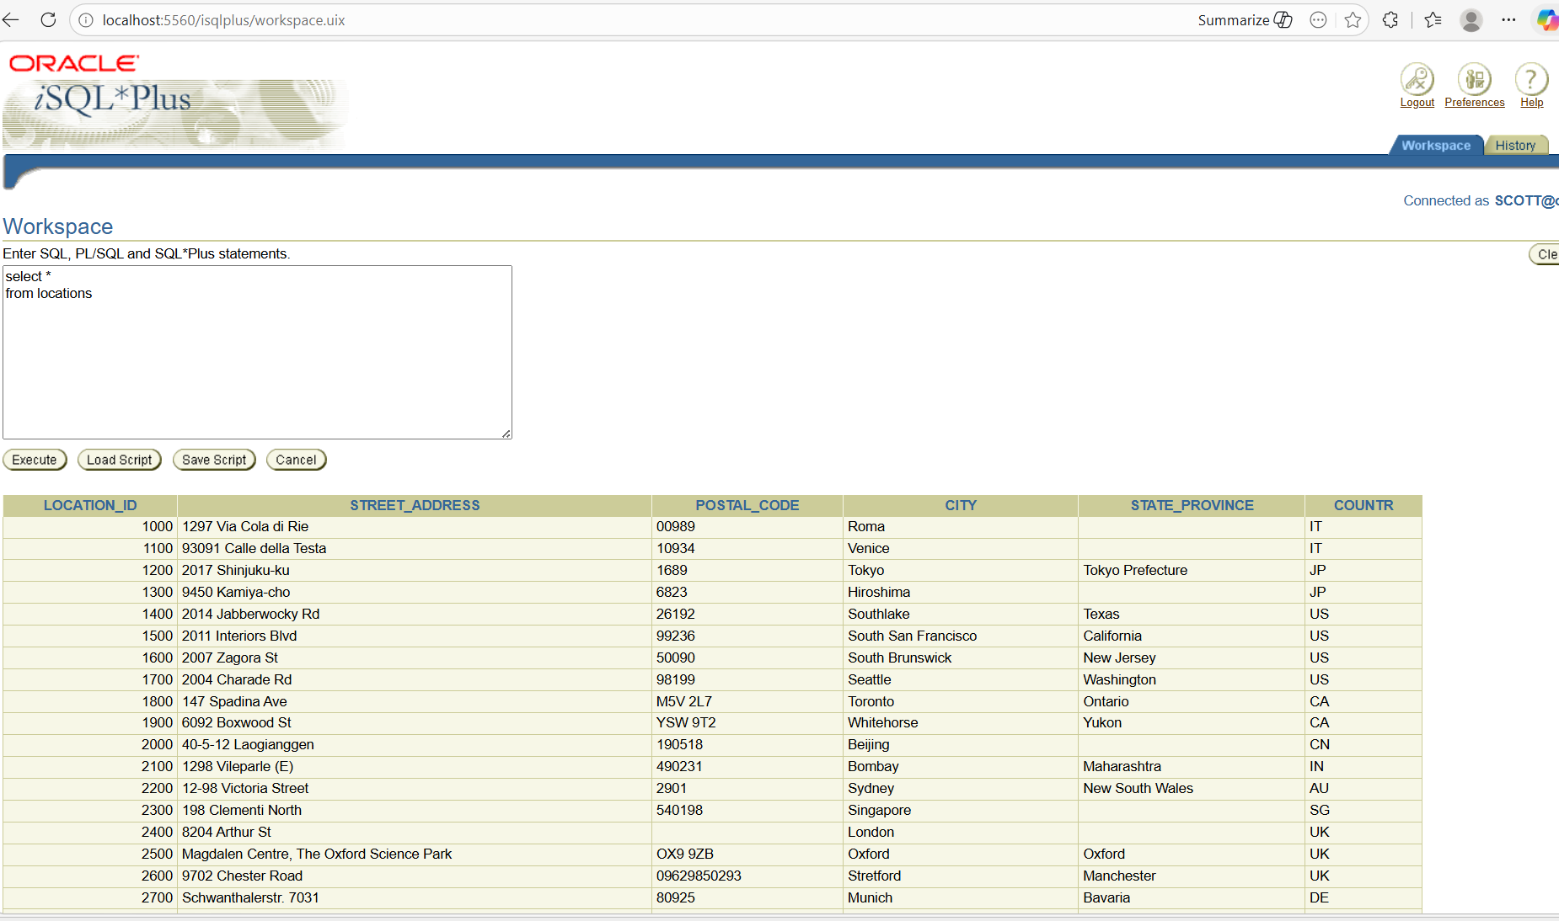

- view its structure

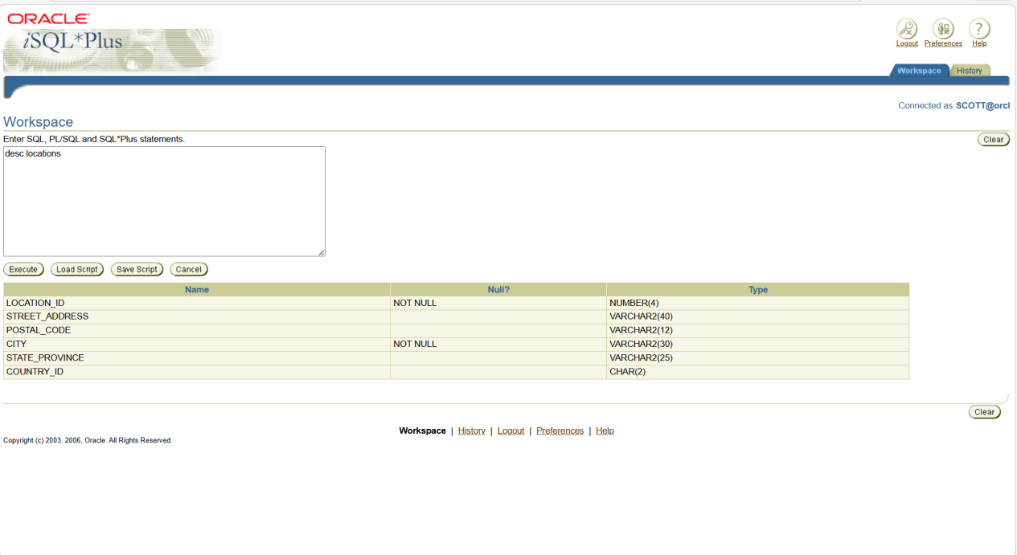

Question 2

Show structure of EMPLOYEES table and create a report

- Show internal structure

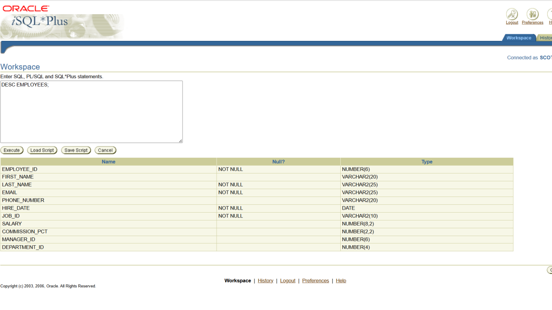

- Display required employee report

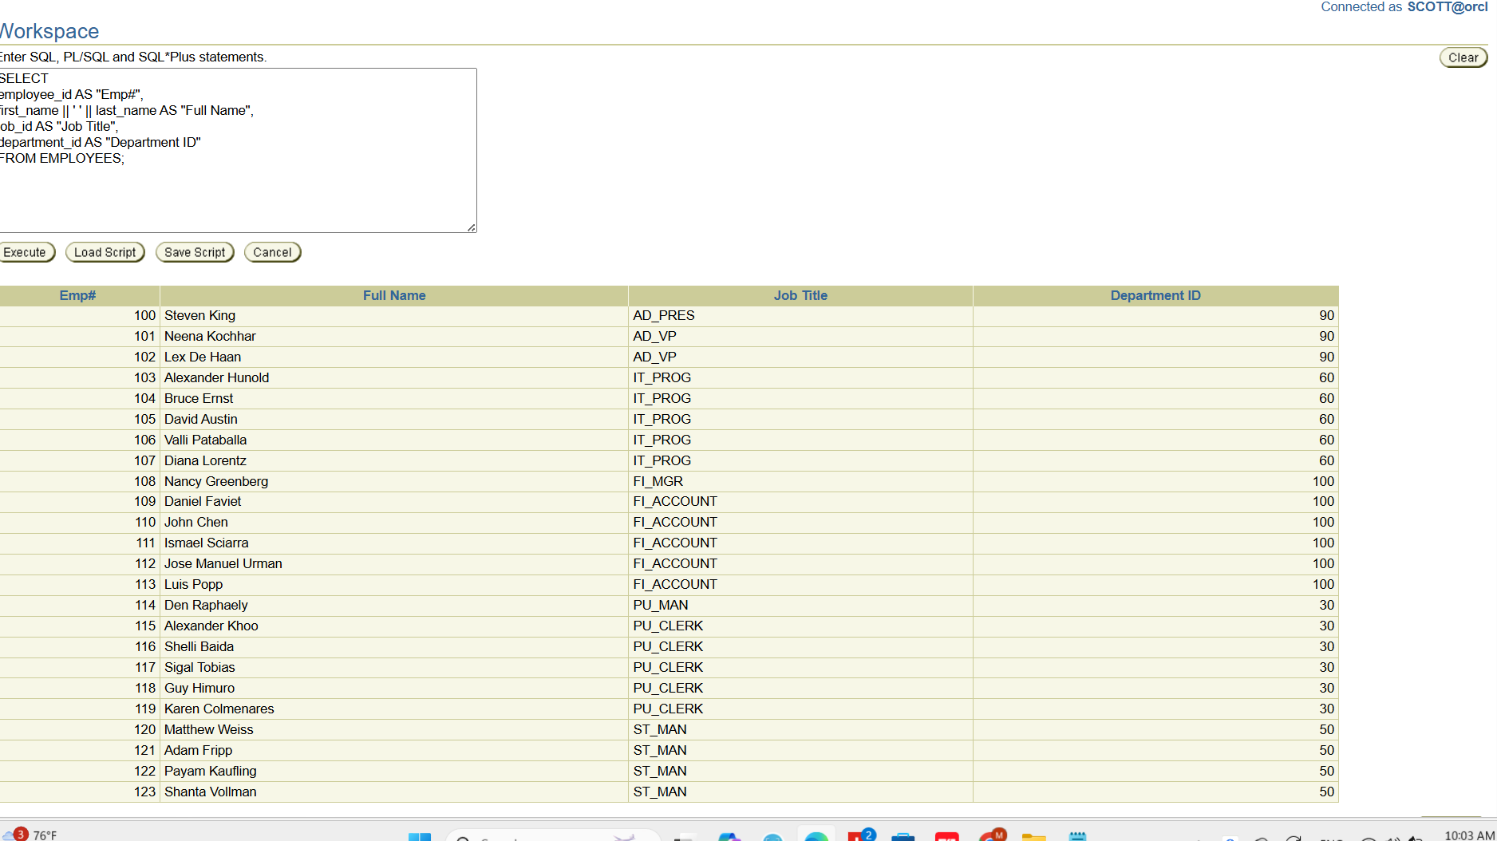

Question 3

Display unique job titles from EMPLOYEES

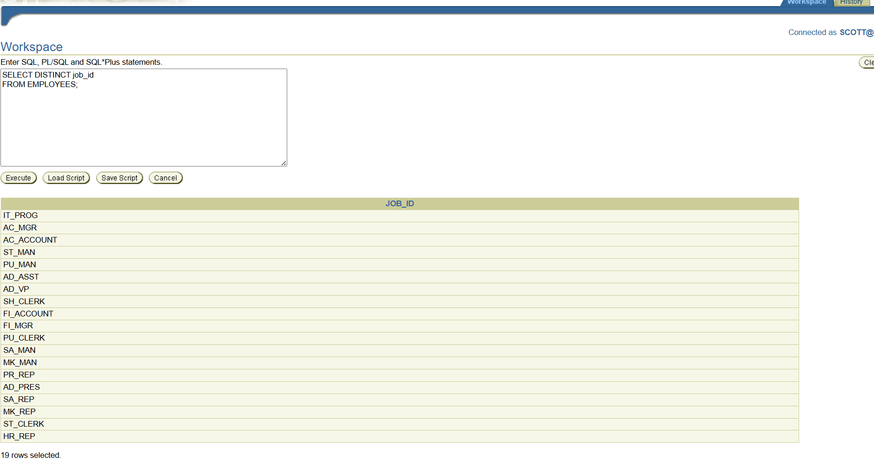

Question 4

Display employees full name with phone and email

